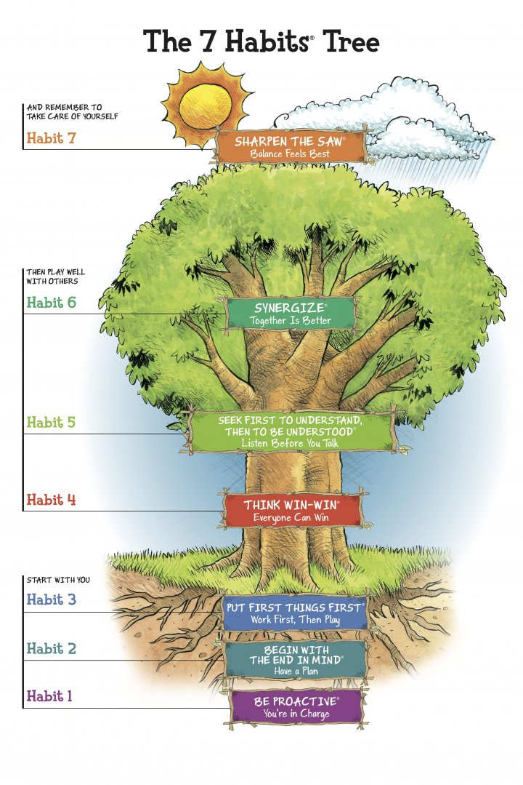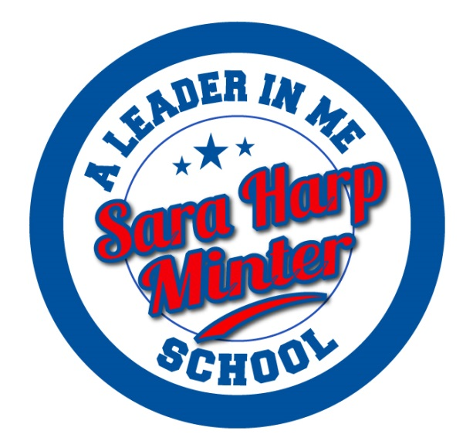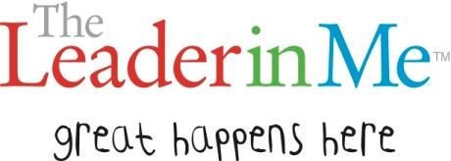

Habit 1: Be Proactive (You’re in Charge)

I am a responsible person. I take initiative. I choose my actions, attitudes and moods. I do the right thing, without being asked, even when no one is looking.

Habit 2: Begin with the End in Mind (Have a Plan)

I plan ahead and set goals. I am an important part of my classroom and contribute to my school’s mission and vision, and look for ways to be a good citizen.

Habit 3: Put First Things First (Work First, Then Play)

I spend my time on the things that are most important. This means I say no to things I know I should not do. I set priorities, make a schedule, and follow my plan. I am disciplined and organized.

Habit 4: Think Win-Win (Everyone Can Win)

I balance courage for getting what I want with consideration for what others want. I make deposits in others’ Emotional Bank Account.

Habit 5: Seek First to Understand, Then to Be Understood (Listen Before You Talk)

I listen to other people’s ideas and feelings. I try to see things from their viewpoints. I listen to others without interrupting. I am confident in voicing my ideas. I look people in the eyes when talking.

Habit 6: Synergize (Together is Better)

I value other people’s strengths and learn from them. I get along well with others, even people who are different from me.

Habit 7: Sharpen the Saw (Balance Feels Best)

I take care of my body by eating right, exercising, and getting sleep. I spend time with family and friends. I learn in lots of ways and lots of places, not just at school. I take time to find meaningful ways to help others.

#### 7 Habits

We only get one chance to prepare our students for a future that none of us can possibly predict. What are we going to do with that one chance?

Steven Covey

[www.saraharpminter.org](http://www.saraharpminter.org/)

[www.facebook.com/saraharp.minter](https://www.facebook.com/saraharp.minter)

Twitter: @saraharpminter

Celebrating Life, One Child at a Time.

**Sara Harp Minter Elementary**

Phone: 770.716.3910

The following responses are from our faculty and staff:

* To be better than the day before.
* To help our students develop character, intensity, and thinking of others.
* To teach children and ourselves to always have a plan, take ownership and work together.
* To create a culture of leadership that impacts our present and future.
* To help each child develop keys to success.
* To empower kids to take control of their actions, learning, talents, and future.
* To touch the whole child. Make life meaningful and purposeful.
* To bring our school together as a group.
* To bring the best out of both the kids and adults!
* To teach students life lessons. It’s not a “character ed” program. It teaches students to lead themselves.
* To make children reach for their goals and become future responsible citizens and caring people.
* To create a culture of leadership within our school and empower students by living the 7 habits.

# *The Leader in Me* is a whole-school transformation model and process—developed in partnership with educators—that empowers students with the leadership and life skills they need to thrive in the 21st century. It is based on secular principles and practices of personal, interpersonal, and organizational effectiveness.

* Starts from a powerful premise—that every child possesses unique strengths and has the ability to be a leader.
* Integrates leadership development into existing school programs, curricula, and traditions.
* Helps students learn how to become self-reliant, take initiative, plan ahead, set and track goals, do their homework, prioritize their time, manage their emotions, be considerate of others, express their viewpoint persuasively, resolve conflicts, find creative solutions, value differences, and live a balanced life.
* Impacts all stakeholders, starting first with the staff of a school, then expanding to students, their families, and the community at large.

For more information about The Leader in Me, visit [www.theleaderinme.org](http://www.theleaderinme.org)



# Great Things Happen Here

* Bucket Fillers
* Mission Statements
* Class and School Jobs
* Synergy Squads
* Book of the Month
* Leaders of the Week
* Habit Showcase
* Student Lighthouse Team
* Staff Lighthouse Team
* Student-led parent nights
* Leader Days/School Events

#### Why are we a Leader in Me school?

#### What Does It Look Like at Sara Harp Minter?

#### What is The Leader in Me?